**UNIT 2**

**The Intelligent Enterprise Strategy of SAP**

### Lesson 1

Adopting an Intelligent Enterprise Strategy 45

Lesson 2

Explaining the Experience Management of an Industry Cloud 49

### Lesson 3

Explaining the Business Technology Platform (BTP)

Exercise 2: Explore the SAP Cloud Platform

57

61

UNIT OBJECTIVES

* Explain the levels business process, applications and technology
* Explain the ideas and innovations of an experience management of an industry cloud
* Explain, that the BTP covers two areas: integration and extension

Unit 2

Lesson 1

# Adopting an Intelligent Enterprise Strategy

## 37

LESSON OBJECTIVES

After completing this lesson, you will be able to:

* Explain the levels business process, applications and technology

### The Strategy of an Intelligent Enterprise

In particular, we'll look at the following topics in this lesson:

* SAP Intelligent Enterprise strategy in a nutshell.
* A deeper look at the three levels of Intelligent Enterprise.

SAP Intelligent Enterprise strategy in a nutshell Intelligent enterprises apply:

* advanced technologies
* best practices
* within Agile and integrated business processes.
* This makes them resilient, successful, and sustainable.

A deeper look at the three levels of Intelligent Enterprise Intelligent enterprises consists of 3 levels:

* 1. Business Processes
  2. Applications
  3. Technology

Let us take a closer look at the three individual areas in the following overview picture.





Figure 20: The Three Levels of the Intelligent Enterprise

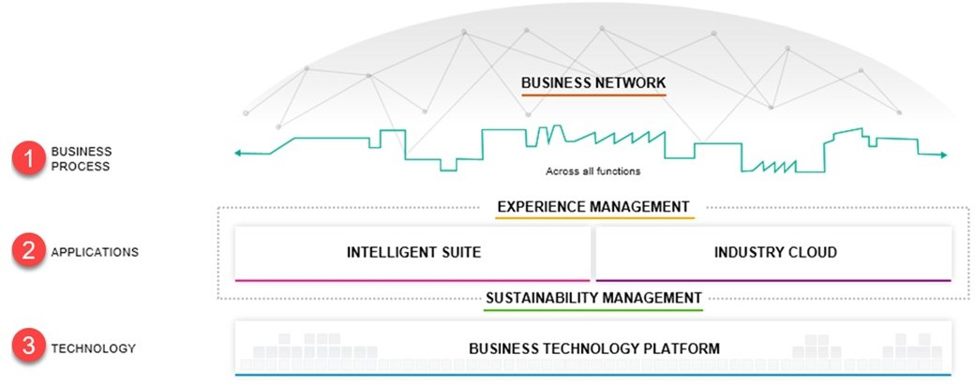Business Processes

The Level Business Process includes the Business Network. The SAP business network will help you to digitalize cross-company business processes. The network builds on current procurement, travel, and contingent workforce solutions to help intelligent enterprises work together to create flexible value chains.

Applications

The Applications includes the Experience Management, the Intelligent Suite and the Industrie Cloud. Experience Management understanding what people want, and how they feel is critical to making the right decisions. Experience management solutions give insight on the sentiments and feelings of customers, employees, and other business stakeholders.

Intelligent Suite:

SAP offers an integrated suite of applications - the intelligent suite- that support your end-to-end business processes. These would be S/4HANA with different deployment options, SAP 3 and the various SaaS solutions such as SuccessFactoirs, Concur, Fieldglass and many more. SAP's industry cloud will enable you to discover and deploy vertical solutions from SAP and partners. Industry means „Core Business".

Industry Cloud:

SAP's industry cloud will enable you to discover and deploy vertical solutions from SAP and partners. Industry - Means Core Business.

Technology

The Technology includes Business Technology Platform (BTP). Being best-run means running sustainably. SAP solutions for sustainability will help customers understand and manage their impact on people and the environment.

The BTP provides data management and analytics, supports application development and integration, and allows you to use intelligent technologies - such as artificial intelligence, machine learning, and the Internet of Things - to drive innovation.

Furthermore, we only want to take a closer look at the Industry Cloud and the Business Technology Platform.

Learn more about Business Network, Experience Management, and Business Suite on https://sap.com.

Lesson: Adopting an Intelligent Enterprise Strategy

How to Explore the Products from SAP for the Intelligent Enterprise What are you going to show?

Show the product page under SAP.com.

Which systems do you need?

Chrome Browser

1. Navigate to <https://www.sap.com/products/intelligent-enterprise.html> Here the TN can find out more about the latest status on IE
2. Navigate to <https://www.sap.com/products/business-technology-platform.html>

Here, the TN will find further jumps on the topics related to the Business Technology Platform:

* + Database and Data Management
  + Application Development and Integration
  + Analytics
  + Intelligent Technologies

1. Navigate to <https://help.sap.com/viewer/index>
2. Show SAP Community.
3. Show SAP Developer Center.
4. Search for SAP Cloud Platform ([https://help.sap.com/viewer/product/CP/Cloud/en- US?task=discover_task](https://help.sap.com/viewer/product/CP/Cloud/en-US?task=discover_task)).
5. Show how the landing page is built, jumps into the different areas.

LESSON SUMMARY

You should now be able to:

* Explain the levels business process, applications and technology

Unit 2

Lesson 2

# Explaining the Experience Management of an

**39** Industry Cloud

LESSON OBJECTIVES

After completing this lesson, you will be able to:

* Explain the ideas and innovations of an experience management of an industry cloud

### Ideas and Innovations of the Experience Management of an Industry Cloud

In particular, we'll look at the following topics in this lesson:

* X-and o data
* Industry - Means Core Business
* New API Framework of the Intelligent Enterprise – SAP Graph and its new Business Model
* Business Process Model
* Business and Technology Services
* Vertical Edge
* The Four Main Use Cases of SAP

X-and O data

Facts about x-and o data

* To get a full view of the customers, to improve your business, you need not only the (o) opaque data but also the (x) behavioral data of these customers.

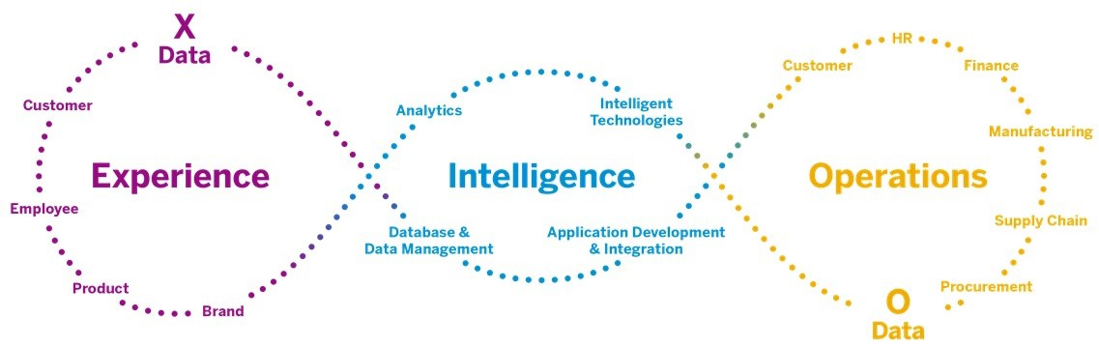This is summarized again in the following picture.





Figure 21: Intelligent Enterprises - Overview

On the left side you can see the experience data that describes the behavior of the business partner, employee, customer or product.

On the right side you can see the operational data, such as functional data of the different modules, as well as the technical data. In between is the Business Technology Platform which combines both data to a complete view of the customer.

In short:

1. Operational data are:
   * All business data
   * All technical data

(x) Experience data are:

All data that directly affects the customer, emotions, opinions, perceptions and many more.

The NEW one:

is now to connect this information. This requires a Technology Platform that allows this, in a simple and wise able way.

The technology platform is the SAP Cloud Platform ( BTP):

It is a portfolio of integrated solutions that accelerate transformation of data into business value. It includes:

* database and data management,
* application development,
* Integration,
* intelligent technologies from on-premise to the cloud.

We will deal with the BTP in detail later.

Industry - Means Core Business Industry cloud is our strategy:

* To extend the intelligent suite with innovative industry cloud solutions.
* Built by SAP and our partners in the cloud.
* Based on SAP Cloud Platform.
* Running on the cloud infrastructure of SAP and our hyperscaler partners.

The intelligent suite offers best practices and support for end to end processes for all industries as the foundation for:

* efficient operations of finance,
* material management,
* supply chains,
* or asset management.

The following picture illustrates the situation





Figure 22: Ideas and Innovations of the Experience Management of an Industry Cloud

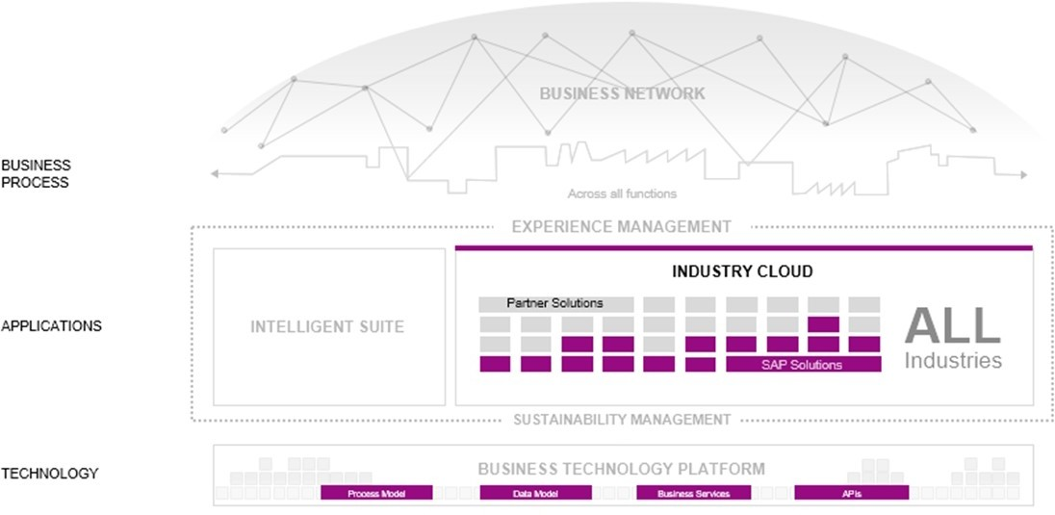In the area of applications, you can see the innovative extensions to the right of the Intelligent Suite. At the moment the focus is on the 4 preliminary processes:

* + Design-to-Operate
  + Total Workforce Management
  + Lead-to-Cash
  + Source-to-Pay

The Intelligent Suite and also the innovative extensions run on the technology layer represented by the BTP.

The open business and technology platform supports in particular in the following areas:

* + Process Modell
  + Data Modell
  + Business Services
  + APIs

Let us take a closer look at the individual areas.

New API Framework of the Intelligent Enterprise – SAP Graph and its new Business Model

In addition to the well-known API's such as REST, OData and SOAP, there is a new innovative API framework based on oData.





Figure 23: SAP Graph

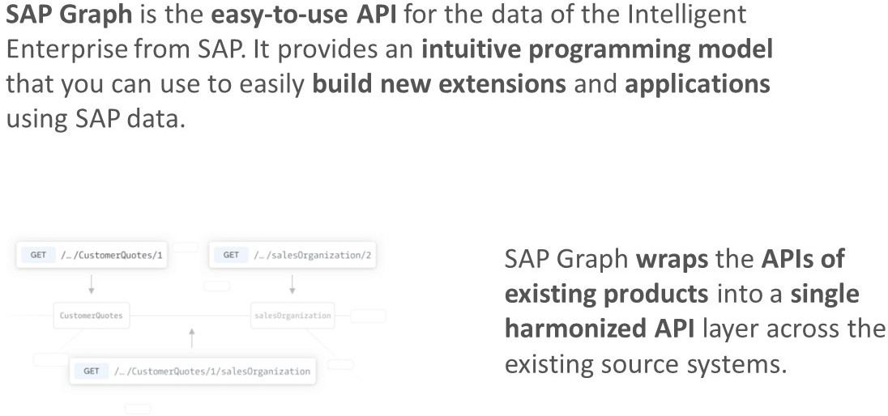More Details:

SAP Graph is an API for accessing SAP-managed data. It exposes the SAP ODM, a unified graph-like domain model of business objects (domain entities, like Products, Sales Orders and Customers) and relationships (links) to users of client applications, hence its name.

Application developers use SAP Graph as a RESTful service to navigate and access the data, regardless of where (in which SAP business or industry-specific system) this data resides, on premise or in the cloud.

SAP Graph uses open standards like OData v.4 as a single access protocol and OAuth for unified authentication. By unifying the data access to a single interface, the entry barrier for extending the Intelligent Enterprise gets lowered significantly. Overall, SAP Graph leads to higher productivity and a better development experience.

If the ODM provides all necessary data objects for your industry cloud solution, you must use SAP Graph. SAP Graph is designed for developers of extension applications.



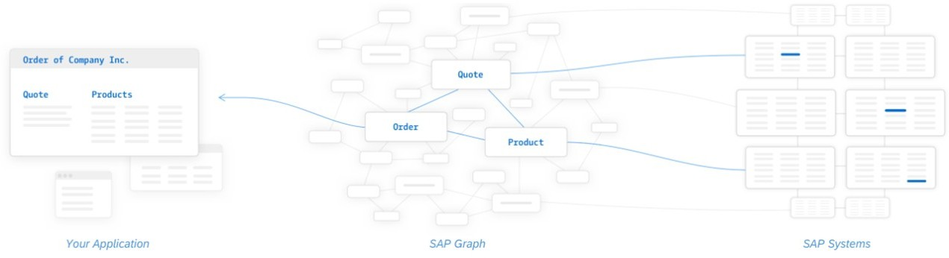

Figure 24: Schematic Overview of SAP Graph

The figure shows a schematic overview of SAP Graph.

SAP Graph combines the data from different business domains. Here e.g. products, quotas and orders and makes them available as OData. It is more than just views of technical data as it is based on a new business domain model.

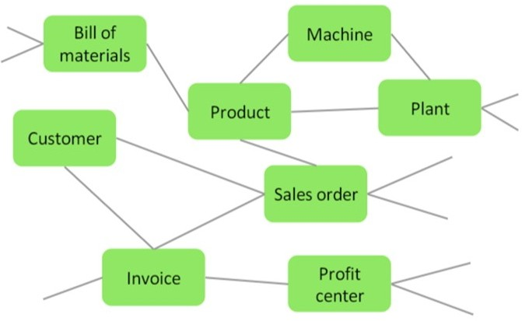Business Modell of SAP Graph





Figure 25: Schematic Overview of the new Business Model of SAP Graph

The model no longer consists of just one professional domain. Combined models are created along defined processes. This graph approach is used , to connect very large sets of distributed data, to create a dynamic schema and to determine the interconnections between the online actions for the Intelligent Enterprise processes.

SAP focuses on the following processes:

* + Design-to-Operate
  + Total Workforce Management
  + Lead-to-Cash
  + Source-to-Pay
  + And several cross entities

Examples of cross entities are :

* + Bank Identifiers
  + Budget Periods
  + Business Partners
  + Checks
  + Company Codes
  + Cost Centers
  + Country Codes
  + Currency Codes
  + And more- see https://beta.graph.sap

How to Use SAP Graph

1.

### The Business Process Model

Business Process Model

The data model, domain model, and APIs are important to give industry cloud solutions access to the end-to-end process support in the intelligent suite. Understanding the effects of invoking an API that creates, deletes, or changes an object in the intelligent suite requires a business process model that describes the side effects of those operations.

SAP provides the business architecture framework serving as the foundation that helps developers design, build, test, and validate industry cloud solutions.

Each industry cloud solution also comes with content from SAP Model Company services and content that describes how to configure the intelligent suite to enable plugging in the solution.

Business and Technology Services

Industry cloud solutions have ready access to a broad range of business and technology services that make life easy for developers.

These range from simple business services such as currency or unit conversion to Leading edge artificial intelligence and machine learning libraries. With user experience libraries, solution designers can give users a seamless experience as they run end-to-end processes that span multiple industry cloud solutions, the intelligent suite, and business networks.

Subscription management, invoicing, usage monitoring, and application support are also managed through integrated central services.

Vertical Edge

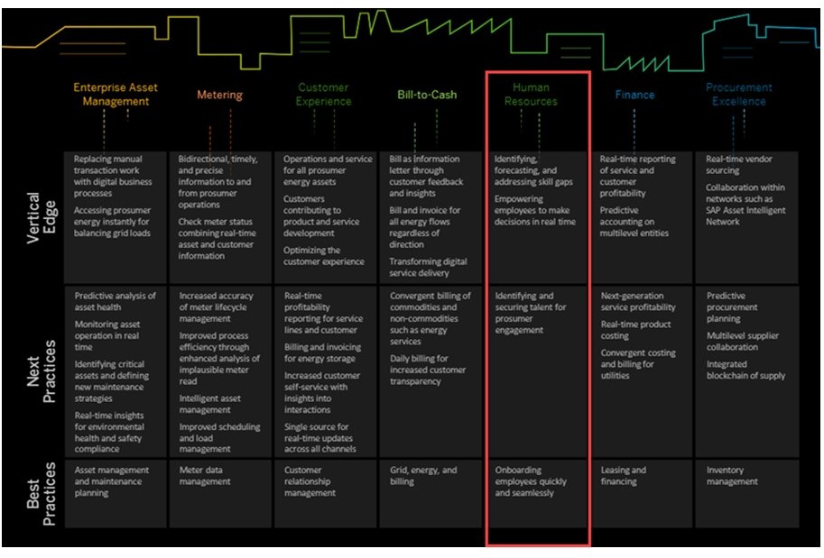Every path needs goals and waypoints. On the way to the Intelligent Enterprise, SAP describes goals and waypoints for several industries. The goals are known as vertical edges.





Figure 26: Innovation Spaces for the Industries

The individual industrial sectors are divided into columns. The journey begins from below. Taking Human Resources as an example, this looks like this.

Further Facts:

Best Practices - Now

Onboarding employees quickly and seamlessly.

Next Practices - Next Step

Identifying and securing talent for prosumer engagement.

Vertical Edge - Goal

Identifying, forecasting, and addressing skill gaps Empowering employees to make decisions in real time.

The Four Main Use Cases of SAP

In order to make the many innovations, ideas and innovations available to the customer, SAP applies this to 4 selected process.



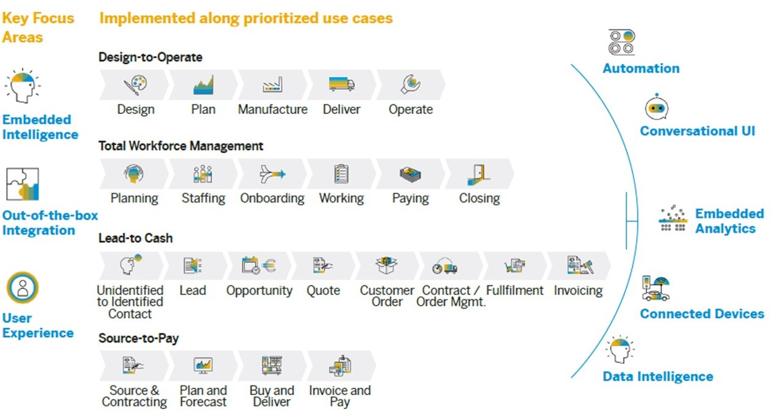

Figure 27: Main Processes in the Intelligent Enterprise

On the picture you can see the four main customer processes that are currently in the focus. The processes are divided into uses cases.

The processes are :

* + Design-to-Operate
  + Total Workforce Management
  + Lead-to-Cash
  + Source-to-Pay

Get Deeper

Design-to-Operate (D2O)

Is the Digital Supply Chain & Manufacturing contribution to the Intelligent Enterprise Suite and delivers a seamlessly integrated Supply Chain which is enriched by intelligent technologies across the entire Digital Supply Chain portfolio:

* + - including Design,
    - Plan,
    - Manufacture,
    - Deliver,
* and Operate solutions,

primarily from a Manufacturer and Operator perspective, with a principle focus on manufacturing industries in the initial delivery.

Total Workforce Management

Manages all aspects of the total workforces (employees and external workers) in line with company's business objectives and a clear line of sight into the financial impact. It enables the end-to-end business process of planning, sourcing, and managing the total workforce, and facilitates a holistic talent strategy to achieve agility and game-changing business outcomes.

The Total Workforce Management includes all the activities needed to maintain a productive workforce, such as:

* the Core HR management,
* performance and training
* management,
* but also recruiting,
* forecasting,
* etc.

Lead to Cash

Typically one of the most important business process for many companies, because it is the process ultimately responsible for driving revenue for an organization. From a high level perspective, the Lead-to-Cash process connects a customer's interest to buy (SAP C/4 HANA) to a company's realization of revenue (in the back-end SAP S/4HANA system), bringing the front office together with back office.

Source-to-Pay

While companies often focus on revenue, sourcing and procurement savings can increase profits about five times more. In the Intelligent Enterprise process definition, both the steps - Sourcing and Procurement are comprised - with Sourcing being the strategic process of ensuring, e.g that the right suppliers get chosen. And Procurement being the operational process that takes care of the actual procurement of direct material, indirect materials, or services

LESSON SUMMARY

You should now be able to:

* Explain the ideas and innovations of an experience management of an industry cloud

Unit 2

Lesson 3

# Explaining the Business Technology Platform

**47** (BTP)

LESSON OBJECTIVES

After completing this lesson, you will be able to:

* Explain, that the BTP covers two areas: integration and extension

### Business Technology Platform

The Business Technology Platform Overview

* 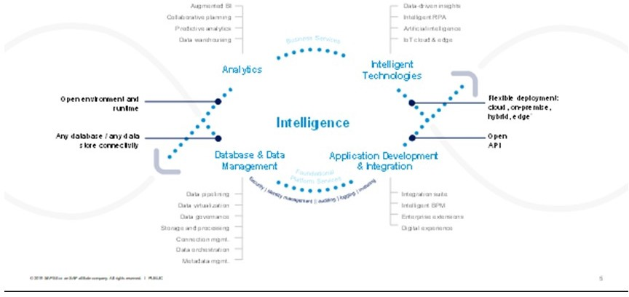The Business Technology Platform is the central cloud-based development platform.





Figure 28: Business Technology Platform

Slide

The figure illustrates, how business intelligence is in the center of all processes. We would like to take a closer look at the following parts:

* Analytics
* Intelligent Technologies
* Application Development & Integration
* Database & Data Management
* Foundational Platform Services

Get Deeper

Business Analytics

Uncover deep insights and simplify access to critical information to drive better business outcomes and accelerate growth.

It focused on:

* Business Intelligence
* Collaborative Planning
* Data Warehousing Intelligent Technologies

Ignite innovation in any area of your business and unlock the intelligent enterprise. Sometimes this is called the Innovation System.

The focus is on:

* Artificial Intelligence
* Internet of Things (IoT)
* Blockchain
* And More.

Application Development and Integration

This is where the Integration Suite and Extension Suite are located.

Extend, integrate, and build enterprise applications with scalable, intelligent, and insightful

Capabilities.

The focus is on:

* Integration
* Enterprise Extensions Database and Data Management

Manage your enterprise data efficiently to optimize analytics and insights and improve business outcomes.

The focus is on:

* SAP HANA and Databases
* Data Intelligence and Orchestration
* Master Data Management
* Information Governance and Metadata Management
* Data Quality and Integration Foundational Platform Services

Services that maximize the flexibility and adaptability of your application investment with a multicloud, future-proof foundation that embraces all major hyperscaler infrastructures and cloud-based, native technologies.

The focus is on:

* Authentication
* Authorisation

Lesson: Explaining the Business Technology Platform (BTP)

* + Logging
  + Monitoring
  + And more

The two Main Areas of the Business Technology Platform

The Business Technology Platform focuses on Application Development and Integration If we look at the Application Development and Integration section more closely, we can

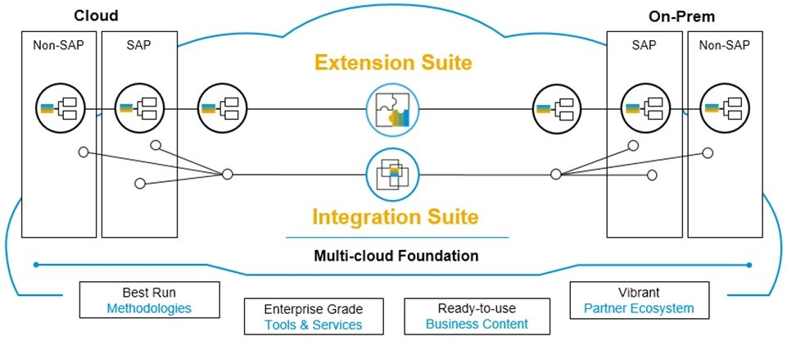identify two basic use cases. The integration and expansion of heterogeneous landscapes, services and processes.





Figure 29: The two Main Areas of the Business Technology Platform

The Cloud Platform consists of two main areas:

* The Integration Suite
* The Extension Suite

On the left-hand side, you see all the cloud systems that are out there in the world, may it be an SAP system or a non SAP system.

And on the right-hand side, you see systems on premise. So here SAP systems with SAP S/ 4HANA or an S/4 Enterprise Suite, for instance, but it could also be non-SAP systems.

Integration Suite Integration Suite

* Makes sure that you have the right data at the right time in the right system whenever you need that.

Extension Suite

The Extension Suite comes:

* with best run methodologies
* and guidance
* and guidelines
* for the customers on how to implement a good user experience, a good process integration, and more.

So we don't just put the tools in place, but we also provide the guidance for the customers to leverage those tools and services and to achieve their goals much faster. Also, on the right- hand side, you see the ready-to-use business content.

So the SAP Cloud Platform is not just a set of tools, it also provides ready-to-use business content that helps you to integrate and extend in the best possible way and in the fastest way.

With the integration and extension suite, we will be working intensively afterwards. We'll take a closer look at the Business Technology Platform - Cloud Platform in a separate chapter

Unit 2

Exercise 2

# Explore the SAP Cloud Platform

## 51

1.

Unit 2

Solution 2

# Explore the SAP Cloud Platform

## 52

1.

Lesson: Explaining the Business Technology Platform (BTP)

LESSON SUMMARY

You should now be able to:

* Explain, that the BTP covers two areas: integration and extension

Unit 2: The Intelligent Enterprise Strategy of SAP